NEWS PORTAL WEBSITE

**Aastha Sharma Mohammad Shahzad**

11701196 11712289

35 27

**Submitted To : Ms. Ruchita Duggal UID : 24930**

**GitHub Link :: https://github.com/Mohammad-Shahzad/PHP_LaravelNewsProject**



**ACKNOWLEDGEMENT**

## IT GIVES US IMMENSE PLEASURE IN BRINGING OUT THIS PROJECT REPORT OF THE PROJECT ENTITLED “NEWS PORTAL” FIRSTLY WE WOULD LIKE TO THANK OUR

TEACHER AND GUIDE PROFESSOR Miss RUCHITA DUGGAL Ma’am WHO GAVE US HER VALUABLE SUGGESTIONS AND IDEAS WHEN WE WERE IN NEED OF THEM. SHE ENCOURAGED US TO WORK ON THIS PROJECT.

## WE ARE ALSO GRATEFUL TO OUR COLLEGE FOR GIVING US THE OPPORTUNITY TO WORK WITH THEM AND PROVIDING US THE NECESSARY RESOURCES FOR THE PROJECT WE WOULD ALSO THANK TO ALL OF THEM WHO HELPED US TO COMPLETE THIS PROJECT.

WE ARE IMMENSELY GRATEFULL TO EVERYBODY INVOLVED IN THIS PROJECT AS WITHOUT THEIR INSPITRATION AND VALUABLE SUGGESTION IT WOULD NOT HAVE BEEN POSSIBLE TO DEVELOP THE PROJECT WITHIN THE PRESCRIBED TIME.

Ms. Ruchita Duggal Assistant Professor

24930

This project is a news portal which contains various categories and news.

Admin has the right to add category, add news, delete and edit news. The portal contains a admin interface. News are of different categories like sports, entertainment, india etc. . Functionalities are Show, Edit, Delete and Create.

**Technologies Used :**

# HTML :

Hypertext Markup Language is the standard markup language for documents designed to be displayed in a web browser.

# CSS :

Cascading Style Sheets is a style sheet language used for describing the presentation of a document written in a markup language like HTML

# Laravel :

Laravel is a free, open-source PHP web framework, created by Taylor Otwell and intended for the development of web applications following the model–view–controller architectural pattern and based on Symfony.

# PHP :

PHP is a popular general-purpose scripting language that is especially suited to web development.

# MaterializeCSS :

Materialize is a modern responsive CSS framework based on Material Design by Google.

**Tools Used :**

* **VS-Code:**

Visual Studio Code is a source-code editor developed by Microsoft for Windows, Linux and macOS. It includes support for debugging, embedded Git control and GitHub, syntax highlighting, intelligent code completion, snippets, and code refactoring.

* **Xampp :**

XAMPP is a free and open-source cross-platform web server solution stack package developed by Apache Friends, consisting mainly of the Apache HTTP Server, MariaDB database, and interpreters for scripts written in the PHP and Perl programming languages.

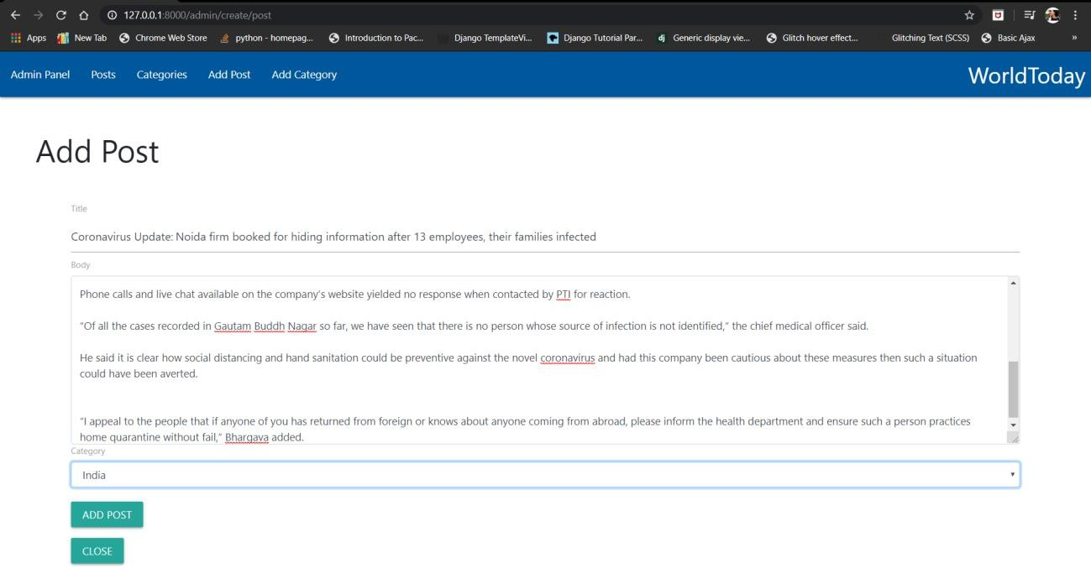**Add Post :**

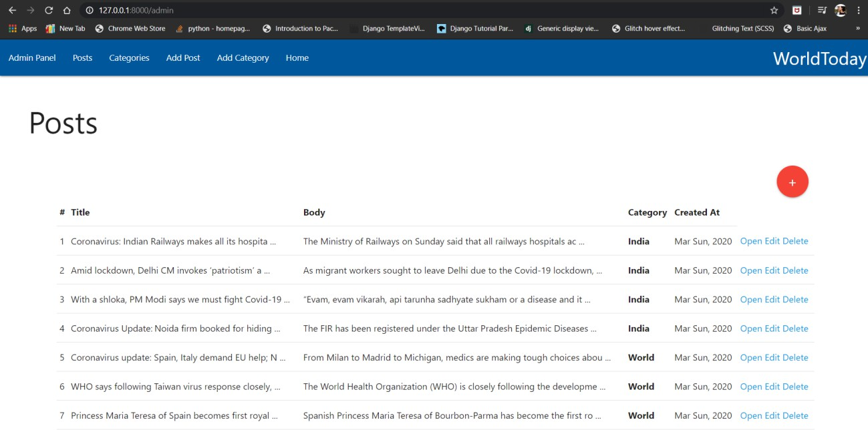**Posts List :**

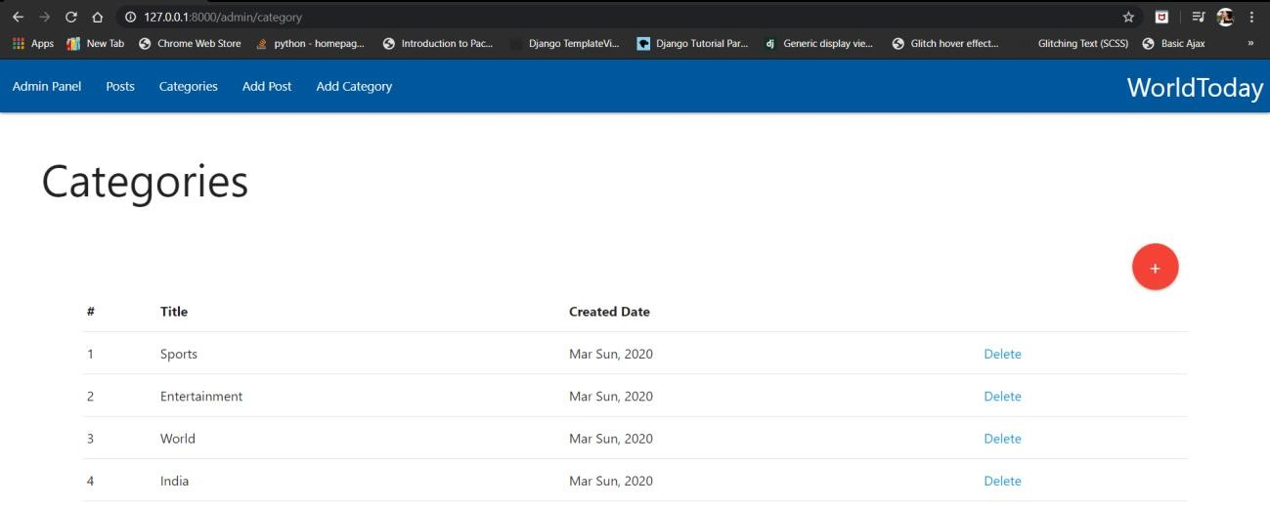**Categories List**:

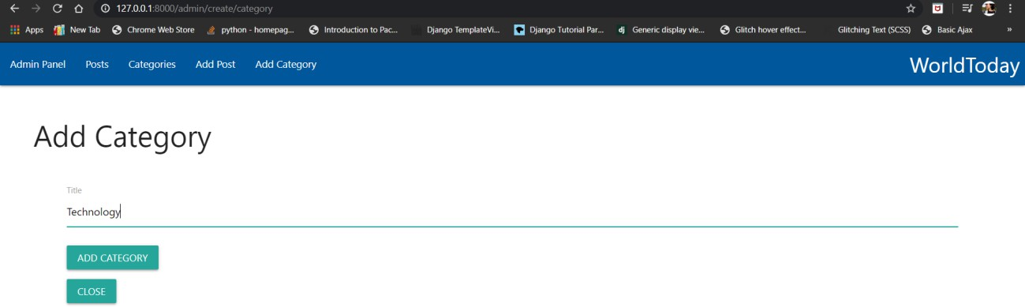**Add Category :**

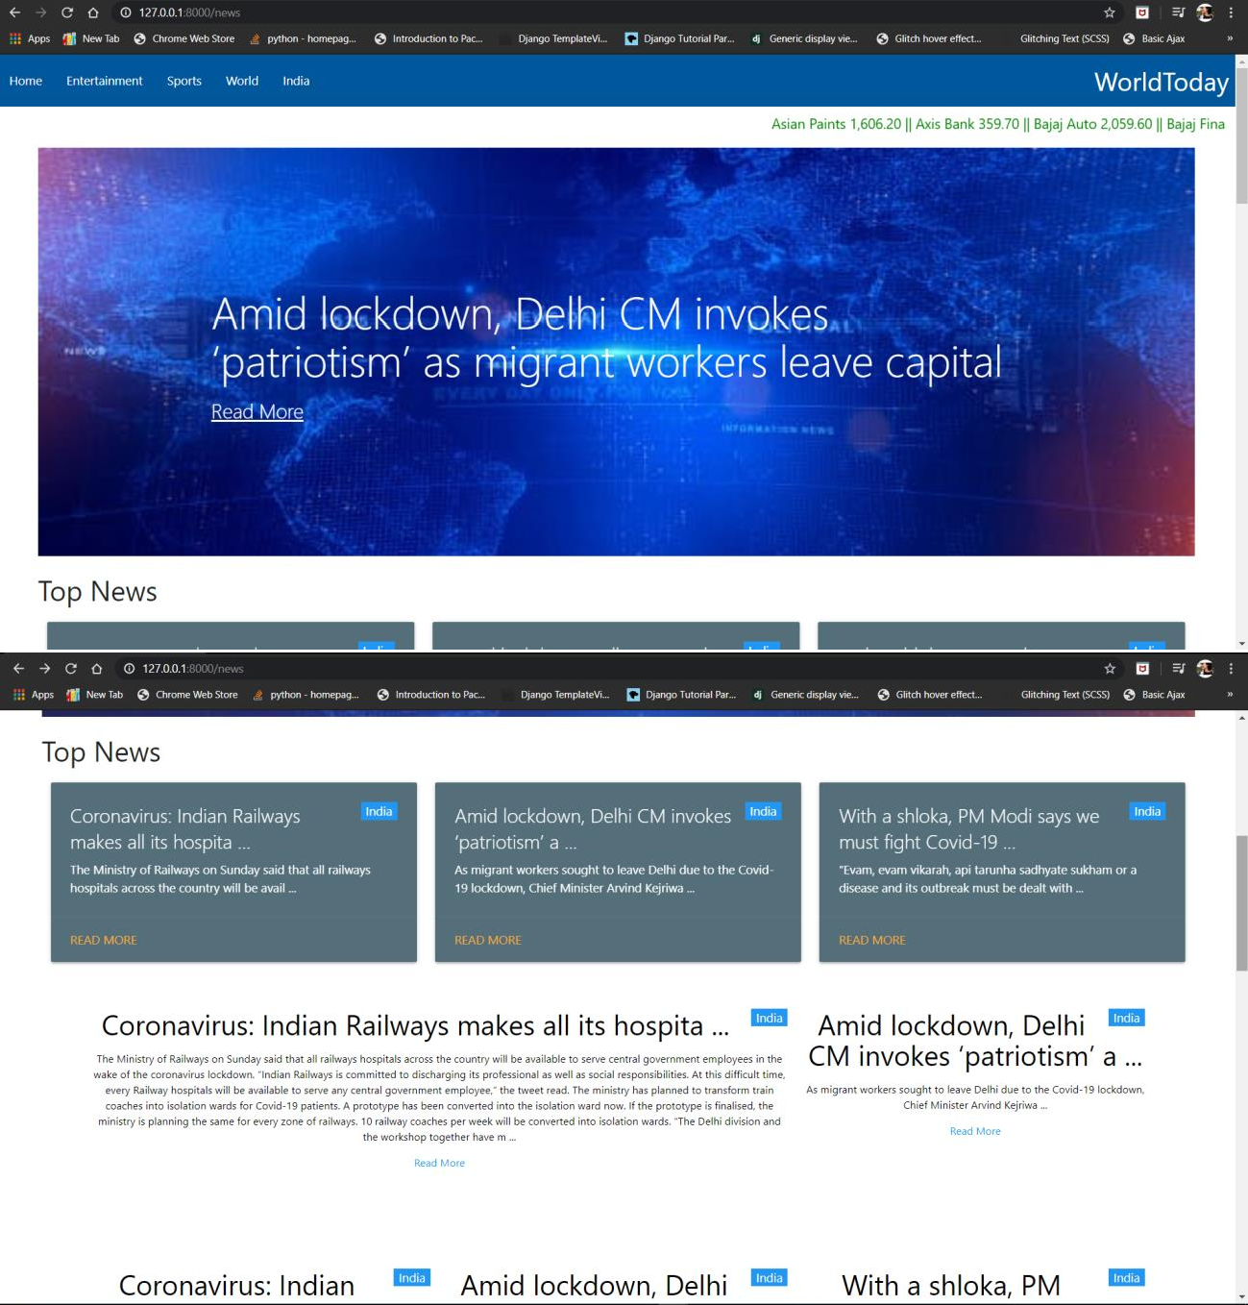**Main Page :**

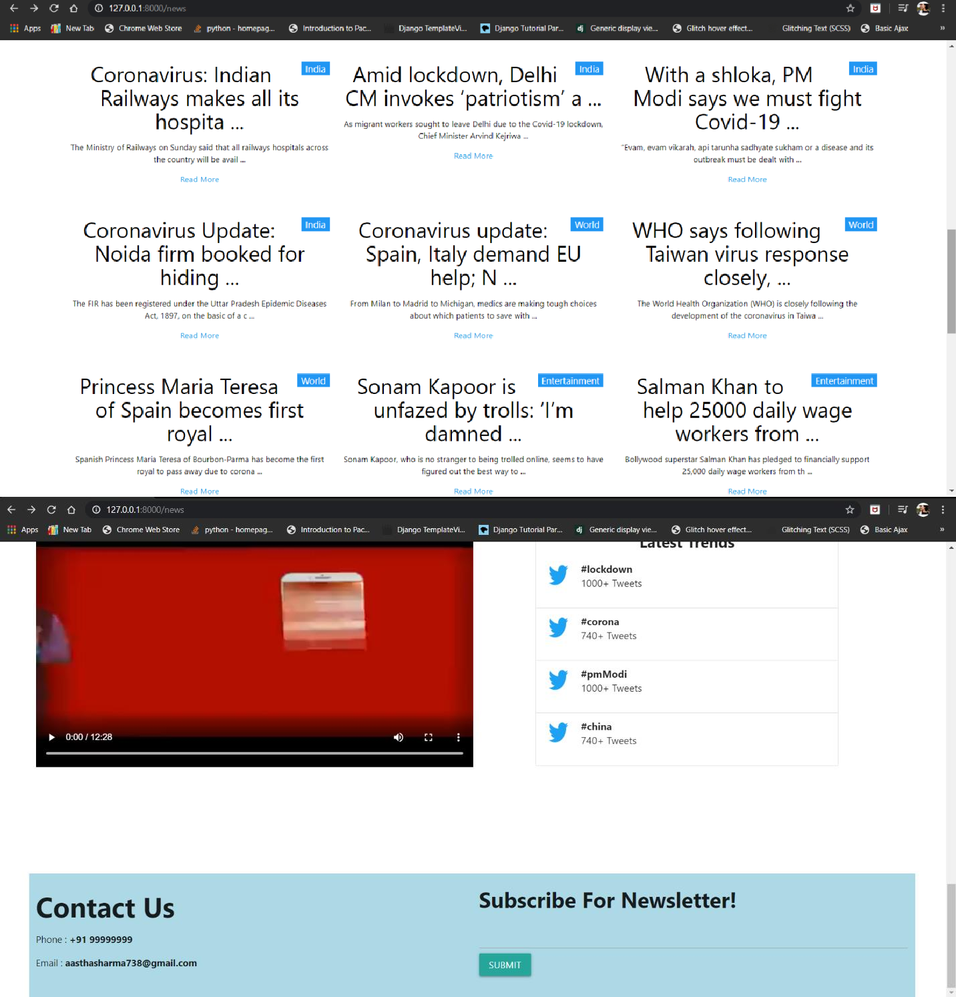

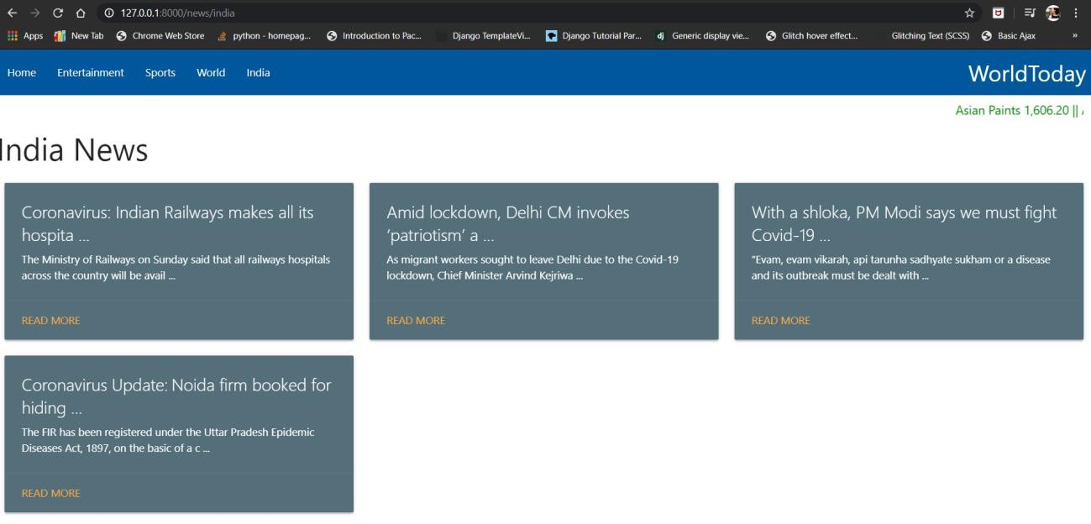**Particular Category Page :**

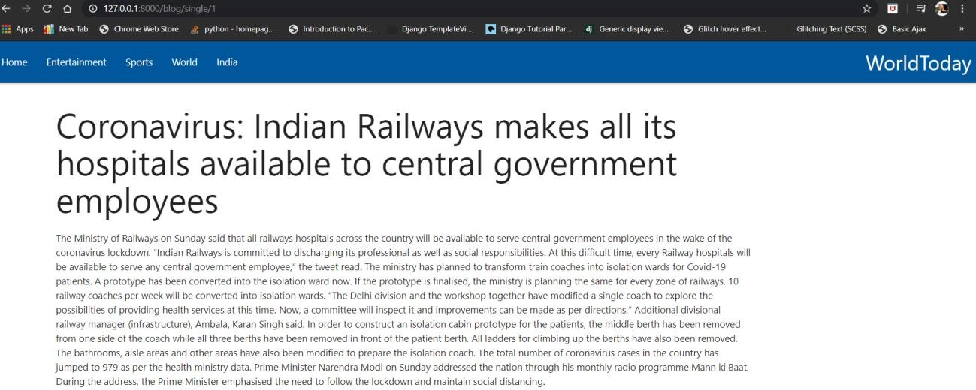**Detail Page :**

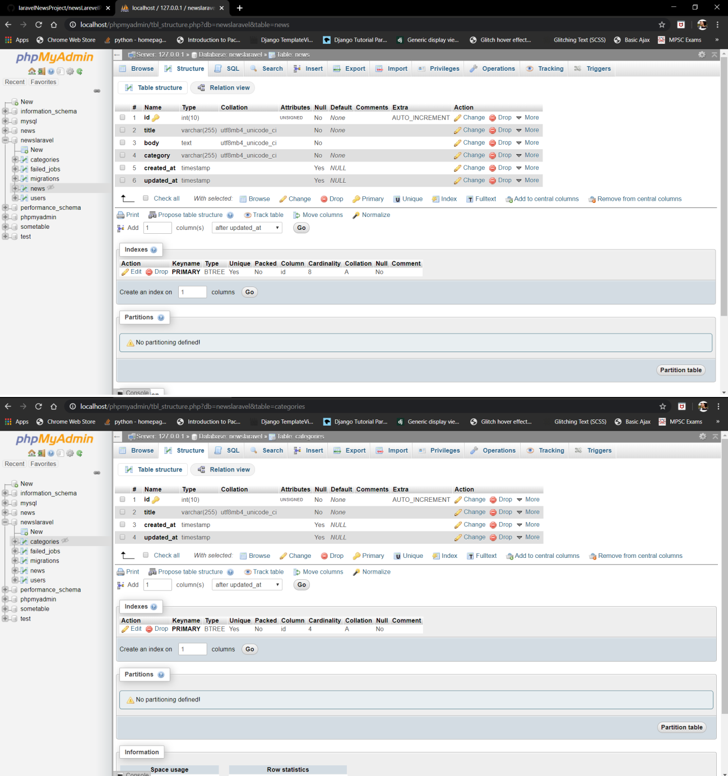**Database :**

**Code Snippet :**

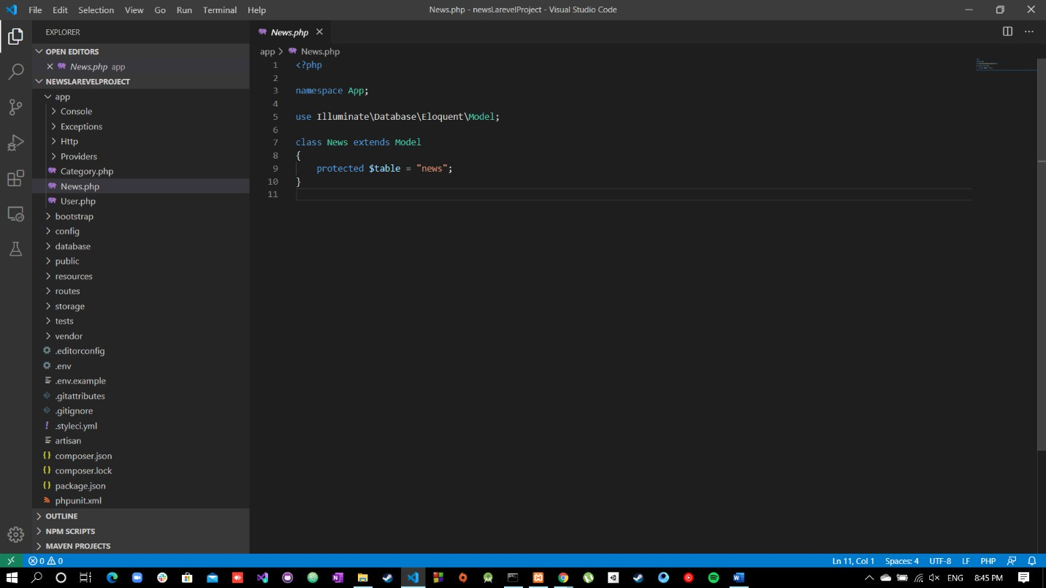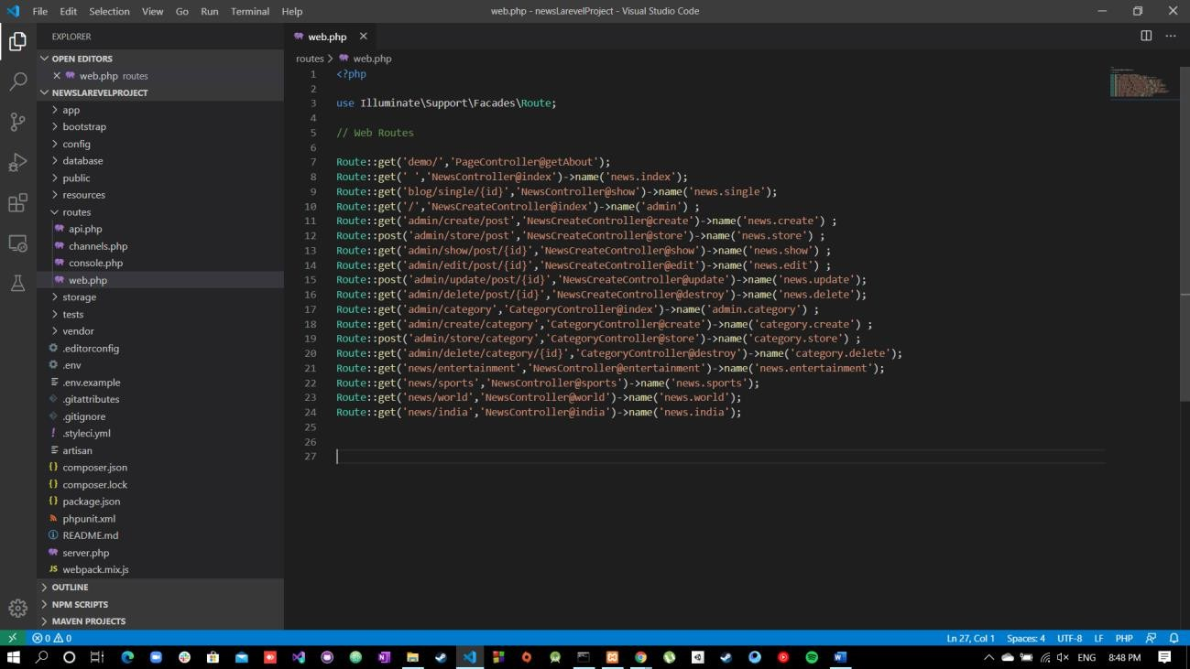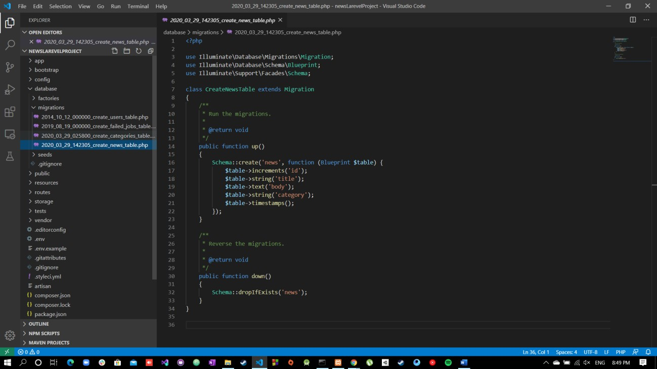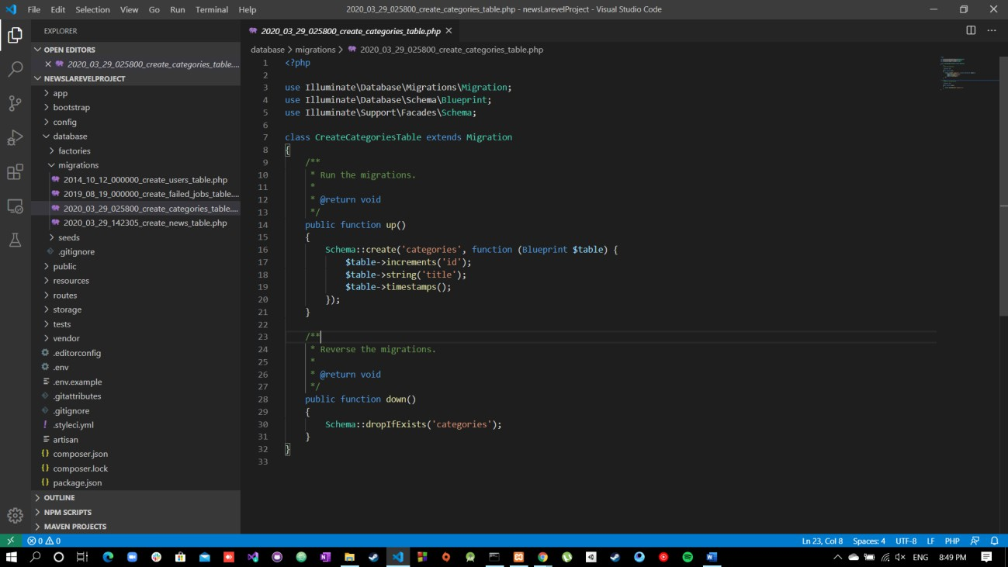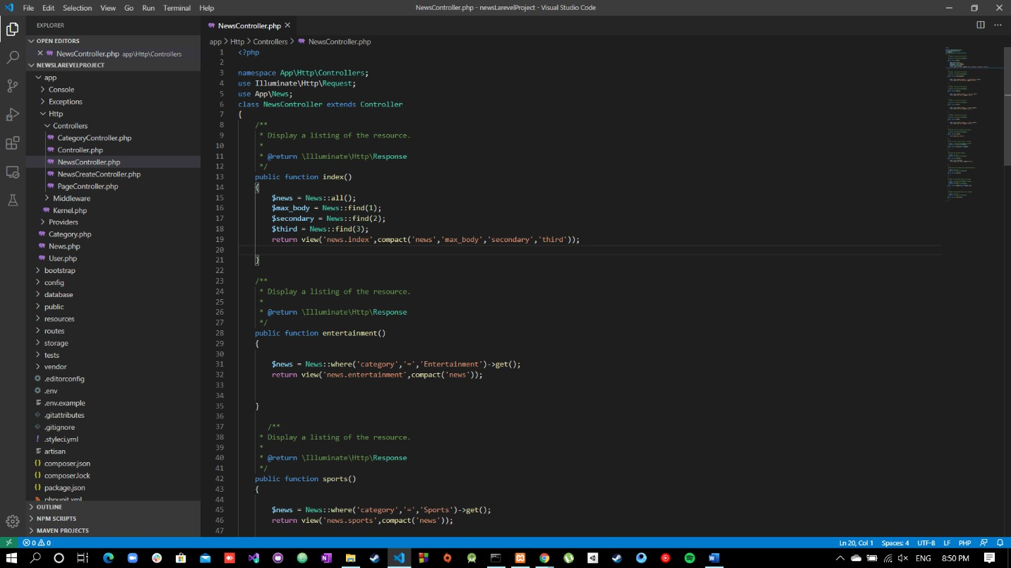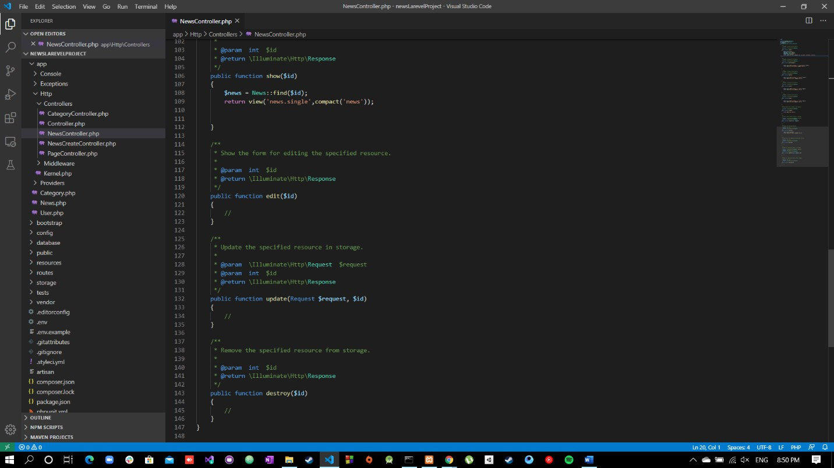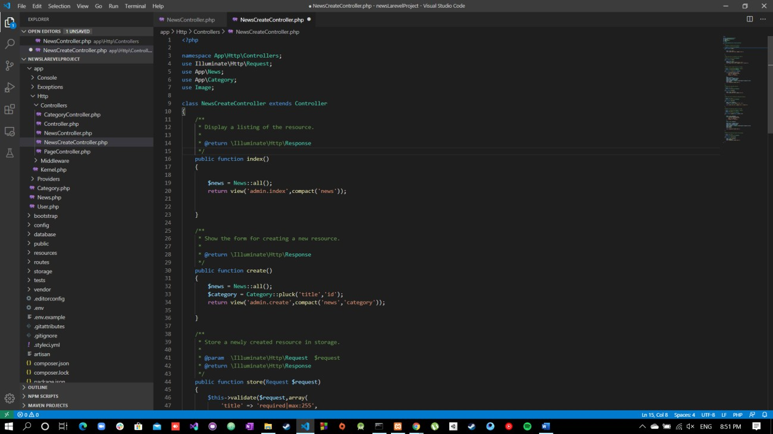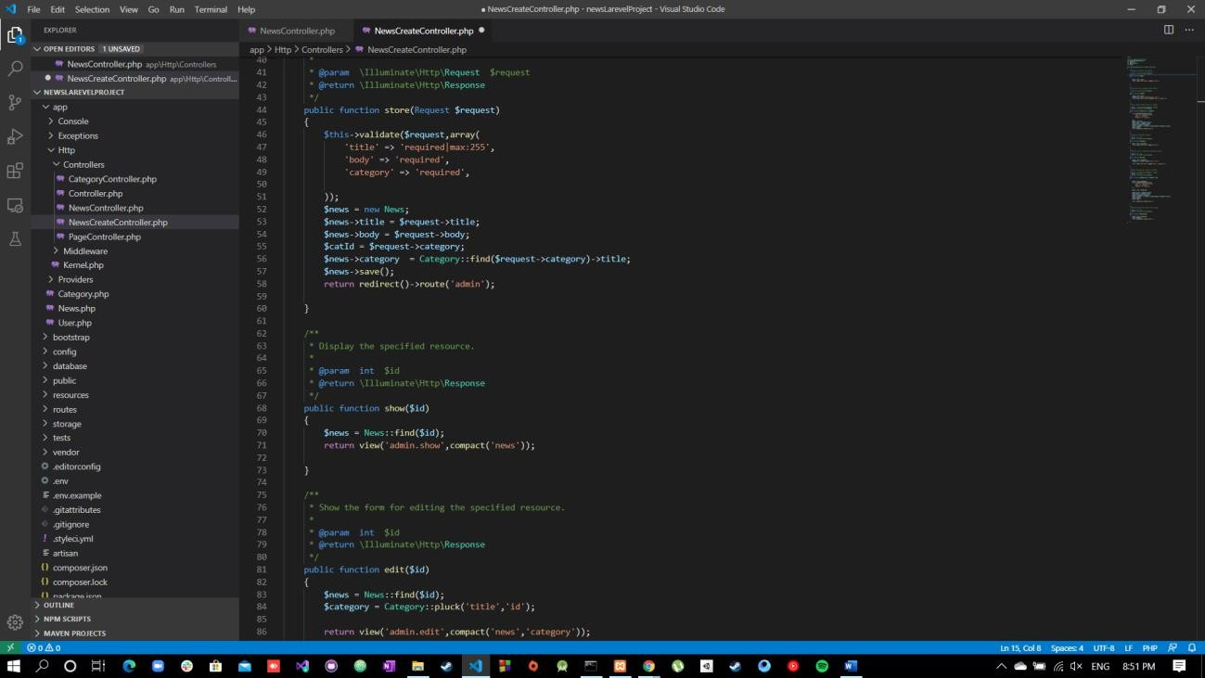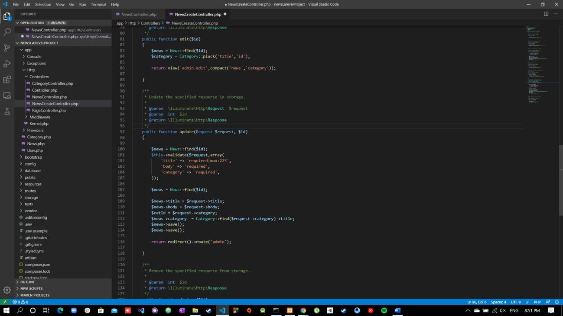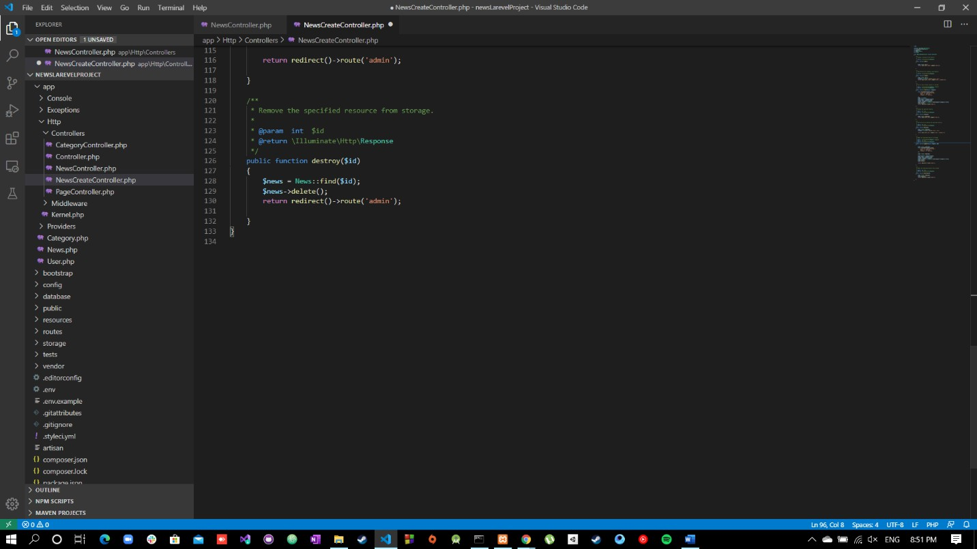

GitHub Link :: https://github.com/Mohammad-Shahzad/PHP_LaravelNewsProject